Brain Games - User Guide

By Arnav Badrish

Contents

# Part 1 – Getting Started……………………………………………….3

* Overview………………………………………………………………………3
* Main Menu…………………………………………………………………..4
* Choose Game……………………………………………………………….5

# Part 2 –Games……………………………………………………………..6

* Image Match………………………………………………………………..6
* Word Blitz…………………………………………………………………….8

# Part 3 – Customization and More………………………………11

* Settings………………………………………………………………………11
* Pause Menu……………………………………………………………….11
* Troubleshooting…………………………………………………………12

Part 1

Getting Started

# Overview

Brain Games is a fun suite of games designed to test your memory. To get started, simply click the Brain Games.exe application that you downloaded. If it does not open correctly or if some functionalities are missing from the application, try restarting or re-downloading the application (see *Troubleshooting* for more information).

To run Brain Games, the following minimum requirements are recommended:

* Any AMD or Intel-based CPU made after 2012
* At least 2 GB of RAM
* At least 50 MB of space
* Windows 7 or higher
* .NET framework 4.0 or higher
* Good headphones/speakers

If the hardware does not meet the given specifications, Brain Games will run, but will not run smoothly and will not be of optimal performance.

# Main Menu

The Main Menu allows you to access all the main features of the game. Begin playing or customise your experience – this is where it all starts.

To exit the game, click the exit button on the main menu to leave the game at any time.

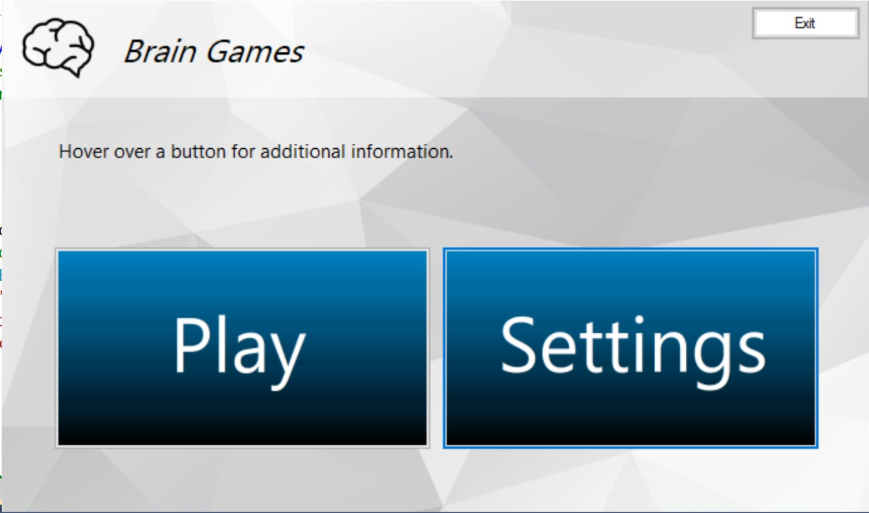

Mix it up! Click Settings to access a game-changing set of options and influence things like sound and background.

Let’s Play! Click Play to access the fun and challenging games that Brain Games has to offer!

By default, background music also plays on this screen on a loop. To disable this feature, go to Settings (See more on *Settings*)

# Choose Game

This is the screen that you will be taken to after clicking the *Play* button in the Main Menu. This screen allows you to select from the two different game modes included in Brain Games.

Click on this button at any time to go back to the Main Menu. This button can be found on almost all the windows in the game.

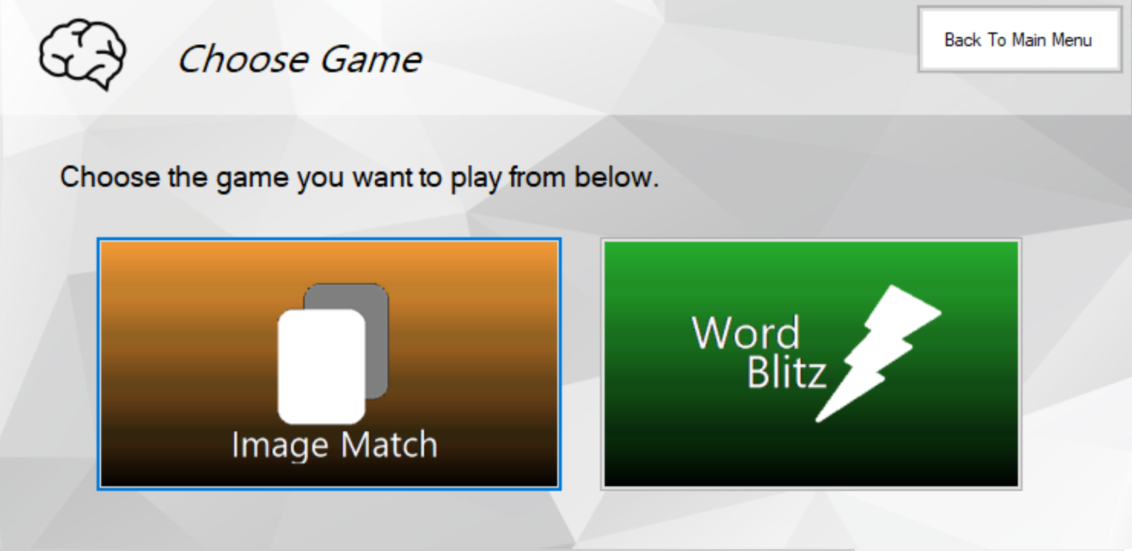

Click on this button to play the Word Blitz game! More details on Word Blitz will be provided in the Word Blitz section of the User Guide.

Click on this button to play the Image Match game! More details on Image Match will be provided in the Image Match section of the User Guide.

Part 2

Games

# Image Match

Image Match is a classic game where you are presented with a grid of images. You can then reveal 2 images at a time, and your goal is to match all the identical images with each other to permanently reveal them – and win!

**Image match – Ready Up Window**

When you first click *Image Match* in the Choose Game window, you will be greeted with a ready-up form. In this window, you can choose the difficulty of your Image Match game. Your best times for each difficulty of image Match will also be displayed on this window, next to their respective difficulty settings.

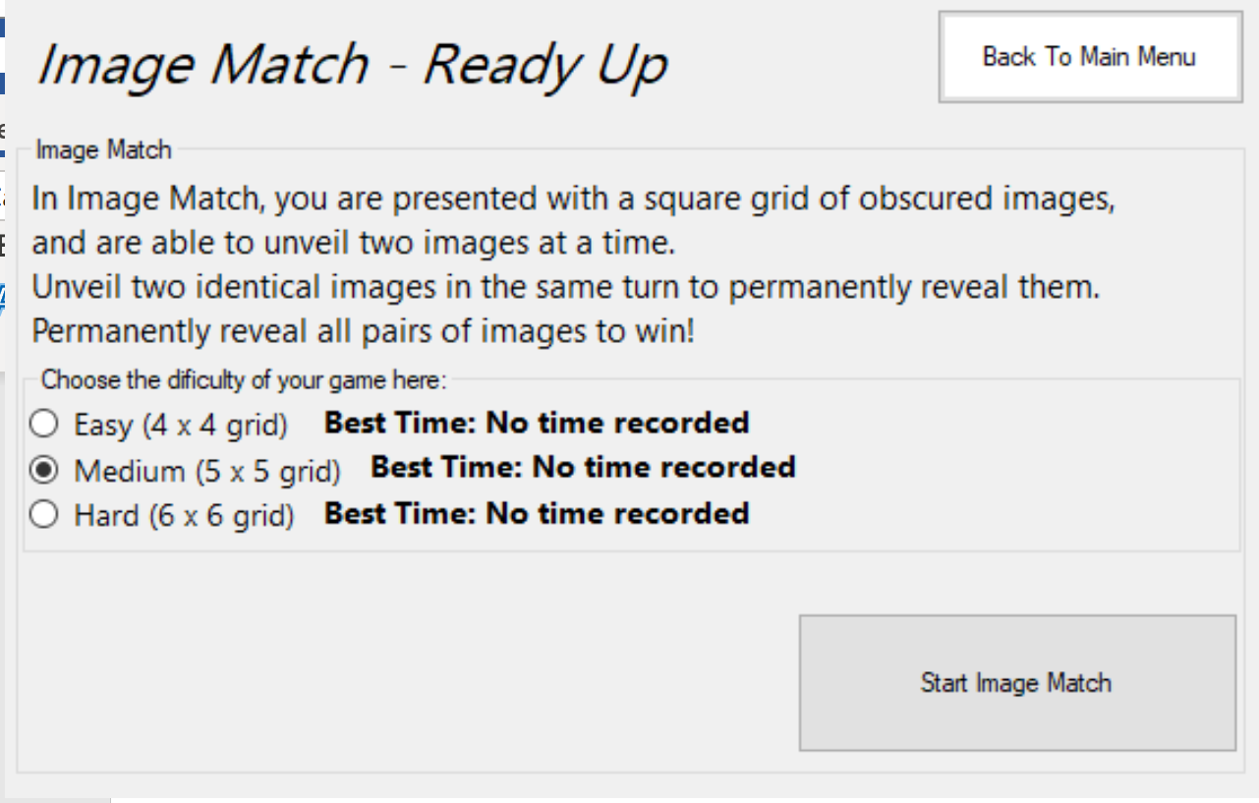

Click on this button to start playing Image Match on the selected difficulty. The timer will start as soon as you press the button.

The best times for each difficulty of Image match will be recorded next to their respective difficulty setting. If no time has been recorded, it will say ‘No time recorded’ instead.

Use these Radio Buttons to select/change the difficulty of your game. It is set to Easy by Default.

**Image Match – Actual Gameplay**

In this screen the Main Menu button has been replaced by a Pause button.

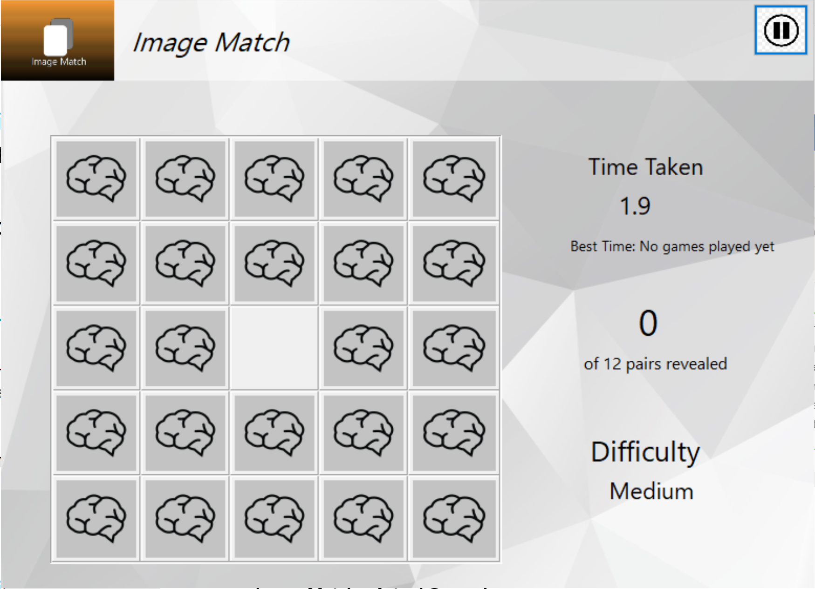

This is the statistics Column. It shows you the time elapsed since you have started the game, the pairs of identical images you have revealed, and the number of pairs you need to reveal in order to win the game, as well as the difficulty of the ongoing game.

This is the game board, whose size will vary depending on the chosen difficulty. Click on a box to reveal the hidden image. You may only reveal two images at a time.

Once you have matched all the pairs on the board, a victory screen will appear, which will display your time taken this round as well as the best recorded time for Image match of your chosen difficulty. If you have beaten your recorded best time, then it will be replaced by your new best. The bottom section of the win screen will indicate this to you.

Clicking the Pause button will take you to the Pause menu and pauses the game. From here you can either go back to the main menu or resume the game. (See *Pause Menu* for more info). Attempting to manipulate any objects in the game while it is paused will result in a warning message being shown.

# Word Blitz

Word Blitz is a brand new and original game mode designed to test your short-term memory.

The game concept: Once the user clicks the *Show* Words button, a certain number of words will flash on the screen in a random order (number of words flashed on the screen depends on the difficulty). After the words are given, a series of textboxes will appear. Your goal is to then type in the words that were flashed into the textboxes **in the order that they appeared** as fast as you can. After you have typed in all the words you remember into the textboxes, click the *Check Answers* button to check your answers. If you entered all the words presented to you in the correct order, then your time will be displayed in the win screen. If your time is better than the best time for the chosen difficulty of Word Blitz, then your time will become the new best time.

**Word Blitz – Ready Up**

When you click *Word Blitz* from the Choose Game window, you will be greeted with a ready-up form. In this window, you can choose the difficulty of your Word Blitz game. Your best times for each difficulty of Word Blitz will also be displayed on this window, next to their respective difficulty settings.

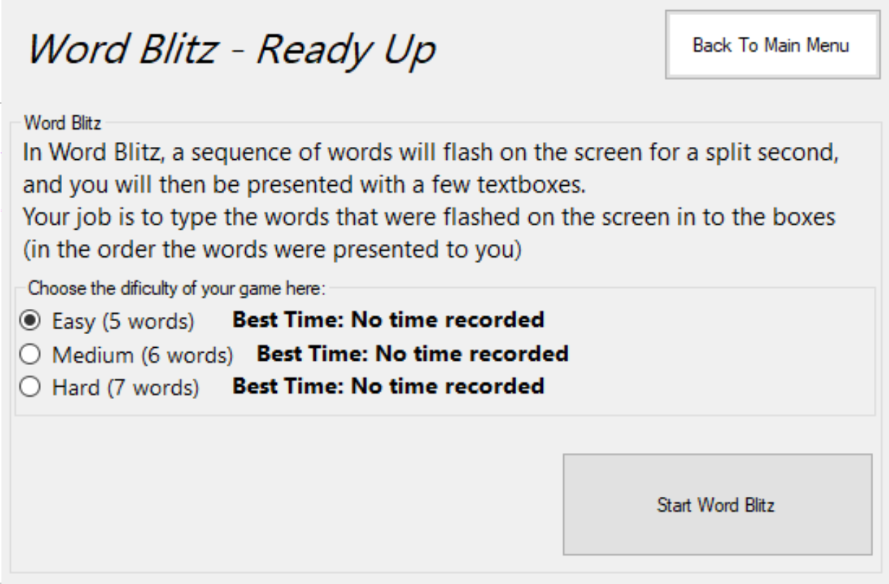

Click on this button to start playing Word Blitz on the selected difficulty. The timer will start as soon as you press the button.

The best times for each difficulty of Word Blitz will be recorded next to their respective difficulty setting. If no time has been recorded, it will say ‘No time recorded’ instead.

Use these Radio Buttons to select/change the difficulty of your game. It is set to Easy by Default.

**Word Blitz – Actual Gameplay**

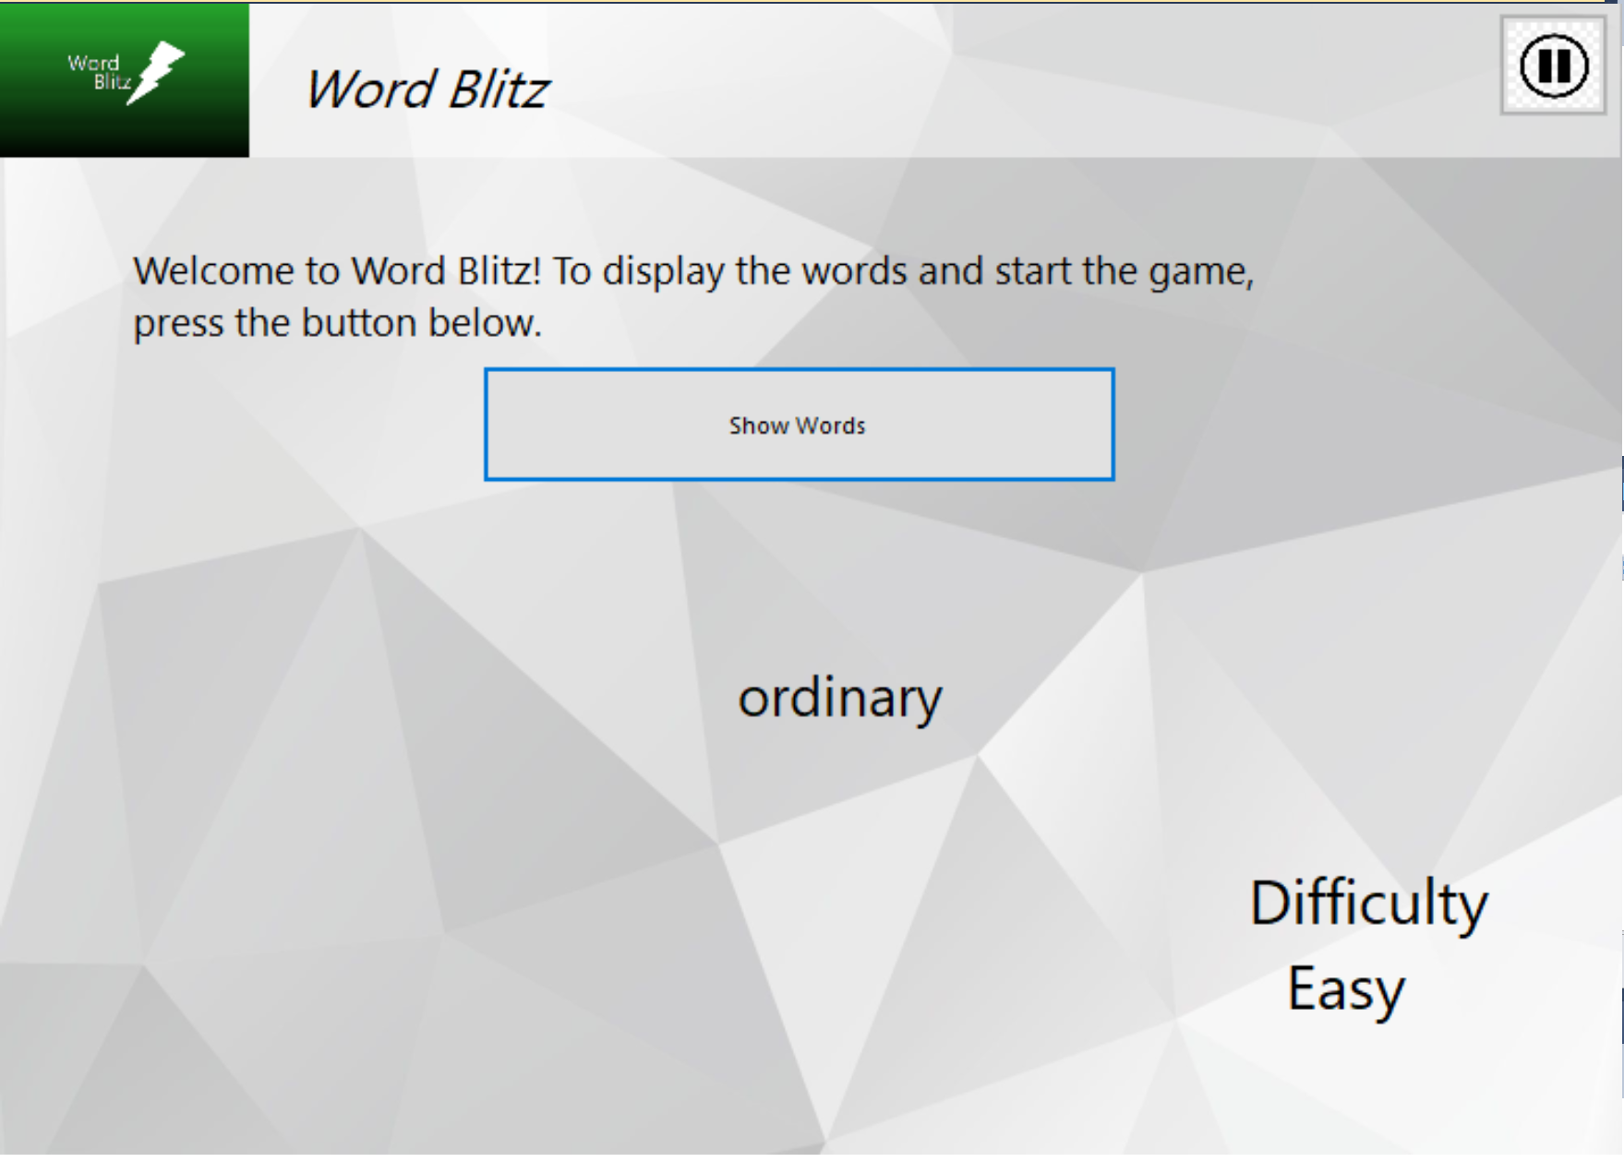

An example of the word being shown on screen for a split second. The words will be “flashed” on screen once the button is clicked.

In this screen the Main Menu button has been replaced by a Pause button.

Once this button is clicked, a series of words will flash on the screen in a random sequence.

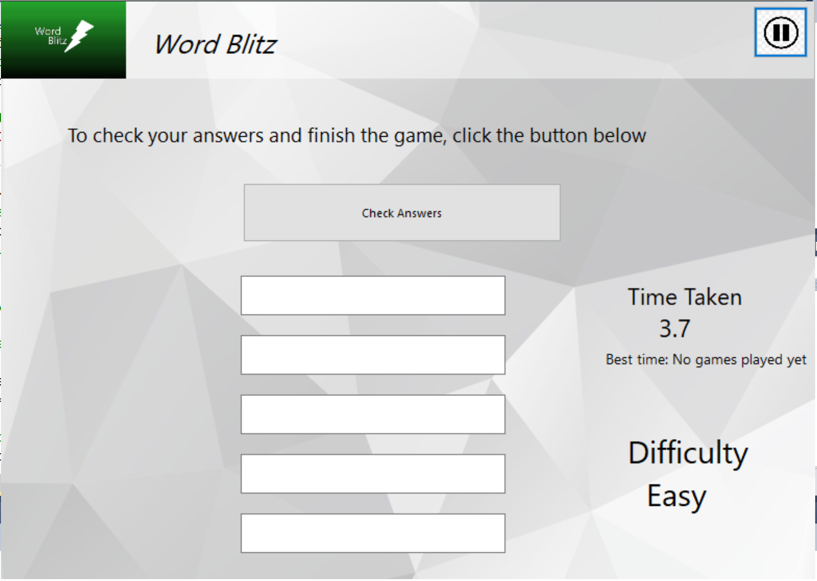

This is the statistics Column. Similar to the column in Image Match, it shows the time taken to type the words into the boxes, the best time and the difficulty.

After you have typed the words you remember into the text boxes, click this button to check your answers.

Textboxes will be displayed on the screen like this. Type each word into a separate textbox.

**PRO TIP: Click TAB while in one textbox to quickly move to the next box.**

If you manage to successfully enter all the words presented in the correct order, you will be presented with the victory screen. However, if you failed to do so, you will be presented with the loss screen, and the correct words will be displayed on the game screen and the cross will be displayed next to the words you got wrong.

To return to the main menu, press the *Back To Main Menu* button on either the victory screen or the loss screen.

Clicking the Pause button will take you to the Pause menu and pauses the game. From here you can either go back to the main menu or resume the game. (See *Pause Menu* for more info). Attempting to manipulate any objects in the game while it is paused will result in a warning message being shown.

Part 3

Customisation and More

# Settings

Settings is an option that can be accessed by clicking the *Settings* button in the main menu. The settings window can be used to customise your game experience.

Click this button to save your preferences and restart Brain Games

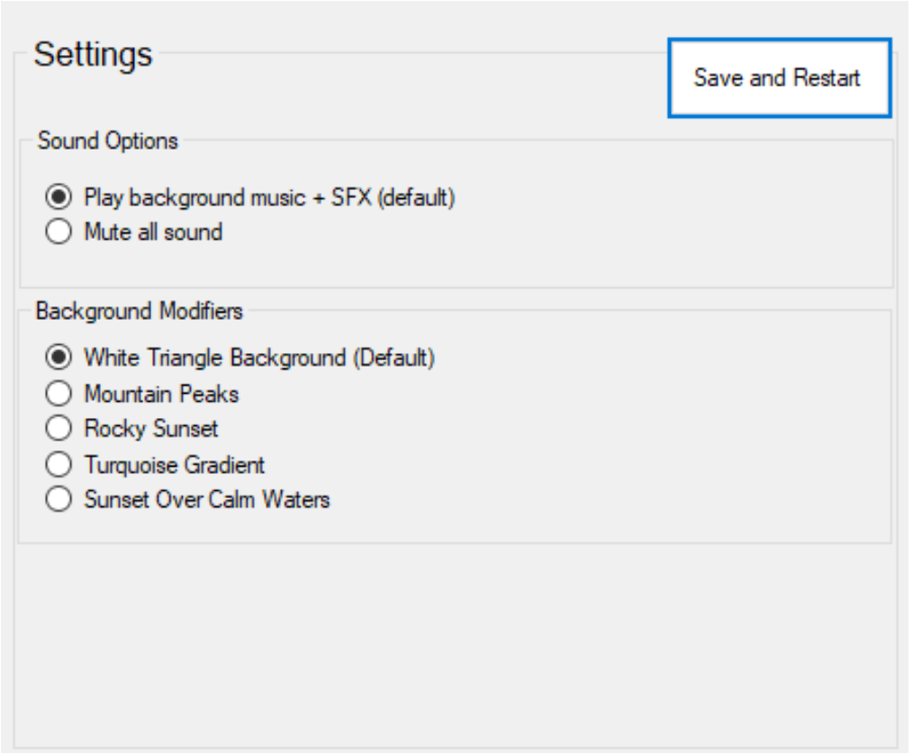

Use the Background modifiers options to change the game’s background to your liking.

Use the Sound Options to enable or disable music and sound effects.

# Pause Menu

The Pause menu is a window accessed by clicking the *Pause* button on either the Image Match form or the Word Blitz form. From here, you can either resume the game, or you can go back to the main menu.

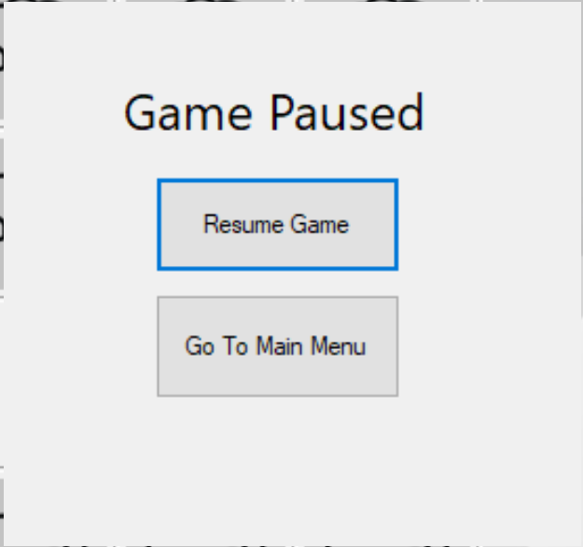

# Troubleshooting

Solutions to some common problems encountered when playing Brain Games.

**Problem:** The soundtracks are not playing properly, and some buttons don’t play sound

**Solutions:**

* First, try checking whether the sound is muted by accessing the *Settings* window from the Main Menu.
* If that does not work, consider upgrading your sound system

**Problem:** The application does not start up

**Solutions:**

* Check whether your anti-virus is blocking the game or some of its features
* Try to run the application with administrative privileges by right clicking on the application on your desktop and selecting “Run As Administrator”
* Ensure that you have a .NET framework of 4.0 or higher

**Problem:** The text is weirdly displayed, and some words look large or are not in the window.

**Solution:**

* This occurs due to your device running a version of Windows below Windows 7, as the game uses typefaces only available in Windows 7 or above. To fix this issue, upgrade your version of Windows.

For any other issues, try deleting and re-downloading the application.

If the problem is still not resolved, please reach out to us and report such problems at braingames.com.